

**TECHNICAL SUPPORT PROCEDURES**

**LAB 2**

Date:

Student ID:

Student Name:

**Network Environment & Configuration Requirements**

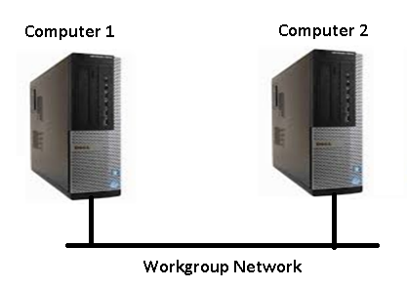

**You are a support technician in a small company that has a few computers in a workgroup environment. Perform and test the following tasks and provide proof of work by way of appropriate screenshots. Each screenshot should be very clear to read.** **Each screenshot should also include the virtual machine name that contains your student id and the date and time of the virtual machine (VM Name G38-XXX and G39-XXX). Assignments with shared or modified screenshots will be rejected. Place the appropriate screenshots after each step.**

1. **Jerry Jones is the local administrator of the workgroup. [5]**
2. **User passwords must be secured against any hacking attempt to access the workgroup computers. [10]**
3. **Mark Shaefer, the CEO of the company, requires access to shared resources on computer 2 from computer 1. Todd Smith and Mona Lisa also need access to administration files stored on computer 2. All shared resources must be stored on a mirrored volume storage pool. [20]**
4. **Mark wants to prevent all employees that use computer 1 from accessing his private files except for Todd his assistant. [10]**
5. **Tara Jennings should be able to access computer 2 desktop remotely from computer 1. [10]**
6. **All employees should be able to use remote assistance services to get help when needed. [5]**
7. **Deny employees from accessing all removable storage on computer 1. [5]**

**Total Marks: 65**

End